Title of Manuscript:
Subtitle

First SURNAME
JLTA University
Second AUTHOR and Third AUTHOR
JLTA High School
Fourth AUTHOR
Graduate School, the University of Testing

Abstract
Abstract should be written within 150 to 250 words in a single paragraph. Do not indent on the first line of the abstract (full justification, Times New Roman, 12 pt.).
- An abstract for an empirical study should describe (a) the research purpose, (b) the participants and their relevant characteristics, (c) the essential features of methods, (d) the main findings, and (e) the conclusions and/or the implications.
- An abstract for a literature review or meta-analysis should describe (a) the research purpose, (b) study eligibility criteria, (c) types of participants included in prior studies, (d) the main findings, conclusions, and implications for theory and/or practice.
- An abstract for a methodological paper should describe (a) the types of methods being discussed, (b) the essential features of the proposed method, and (c) the range of its application.
- An abstract for a case study should describe (a) the participants and relevant characteristics of the individual, group, or organization, (b) the solutions to a problem illustrated by the case example, and (c) the implications for future research and/or theory.

Keywords: test development, validity, reliability, Item Response Theory, placement

(No need to specify the heading)
The present guidelines are mainly based on the Publication Manual of the American Psychological Association (6th ed.) and refer in particular to the 7th ed. for in-text citation and reference list entries. Some phrases were taken directly from them to keep accurate descriptions. The body of the article should be written in Times New Roman, 12 pt., indenting the first line of every paragraph (5-letter spacing).
- No need to specify the opening section of the manuscript as the Introduction.
- Describe the importance of the problem under investigation (e.g., the need to resolve any inconsistency in past studies and/or the need to solve educational problems), with a brief statement of the purpose of the research.

Literature Review
Headings
Table 1 shows the heading style recommended by the APA manual. Each section starts with the highest level (Level 1) of heading. No need to label headings with numbers or letters.

Table 1
Format for Five Levels of Heading in APA Journals
Level | Format
1 | Method  [Centered, Boldface, Uppercase and Lowercase]
2 | Design  [Flush Left, Boldface, Uppercase and Lowercase]
3 | Participants. A total of 162 Japanese university students took ….  [Indented, boldface, lowercase except the first word, a period]
4 | Proficiency level. TOEIC® was used to estimate the ….  [Indented, boldface, italicized, lowercase except the first word, a period]
5 | High school students. The proficiency of the high school students was ….  College students. The proficiency of the college students was ….  [Indented, italicized, lowercase except the first word, a period]
Note. The number of levels of headings needed will depend on manuscript complexity.

Citation
Direct quotation of sources. When quoting any sources directly, always provide the author(s), year, and specific page number. If the quotation consists of fewer than 40 words, incorporate it into text and enclose with double quotation marks as follows:

An important purpose of task-based performance assessments “is to present test takers with tasks that correspond to tasks in ‘real-world’ settings” (Bachman, 2002, p. 471).

If the quotation comprises 40 or more words, display it in block style and omit the quotation marks as follows (leave 5-letter spacing to start a block quotation):

Previous research has indicated the following:
The application of IRT models and methods in educational assessment is now common-place (e.g., see most any recent issue of the Journal of Educational Measurement), especially for large-scale testing firms that employ on their research staff dozens of world-class psychometricians, content experts, and item writers. (Reise & Revicki, 2015, p. 3)
This suggests that ….

Citing references in text. References in JLTA Journal are cited in text with an author-date citation system (e.g., Author, Year) and are listed alphabetically in the reference list. When a work has three, four, or five authors, include the name of only the first author plus “et al.” in every citation, including the first citation, as follows:
- In text: Ishikawa et al. (2010)
- In a parenthesis: Ishikawa et al., 2010
Please see APA 7th pp. 261–269 for details.

Table and Figure Layout
The basic components of a prototypical table are shown in Table 2. When designing and preparing tables and figures, it is good to see Presenting Your Findings: A Practical Guide for Creating Tables and/or Displaying Your Findings: A Practical Guide for Creating Figures, Posters, and Presentations (Nicol & Pexman, 2010 for both publications). File formats of figures preferably include “Microsoft graphic object,” “metafile,” or “bitmap,” which are easily edited. Colored figures are not preferable.

Table 2
Means With 95% CIs and Standard Deviations of Each Test
 |  | Standardized test |  |  |  | Placement test
Group | n | M | 95% CI | SD |  | M | 95% CI | SD
Listening (%)
High school | 40 | 73 | [69, 77] | 13 |  | 75 | [70, 80] | 15
College | 38 | 70 | [65, 75] | 15 |  | 77 | [72, 82] | 15
Reading (%)
High school | 39 | 78 | [73, 83] | 15 |  | 81 | [77, 85] | 13
College | 40 | 76 | [71, 81] | 15 |  | 73 | [68, 78] | 16
Note. Data from two college students for the listening test and a high school student for the reading test were removed from analyses as missing data. CI = confidence interval.

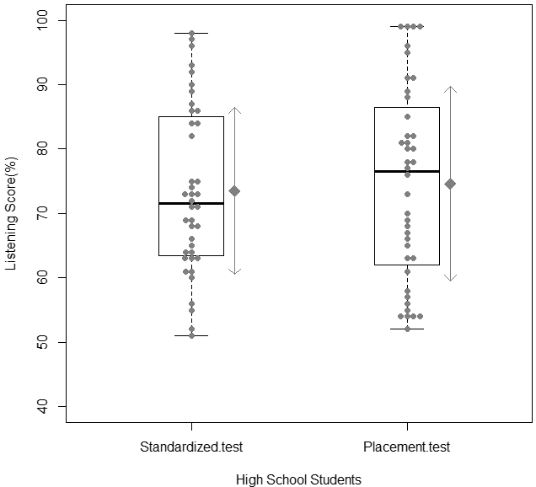
Figure 1. A boxplot of the listening scores for the high school students (n = 40). The boxes represent the interquartile range with the median value; the whiskers represent the maximum and minimum values. The diamonds and arrows represent the means and ±1SDs, respectively.

Method
Participants
Types of headings needed for method, results, discussion, and conclusions sections will depend on a research design. Please see APA 6th guidelines to confirm what elements should be reported in each section.

Materials

Procedure

Results

Discussion

Acknowledgements
This work was supported by JSPS KAKENHI Grant Number JP12345678. We thank AA, BB, and CC for their helpful comments to improve this earlier manuscript.

References
- Books
Bachman, L. F., & Palmer, A. S. (1996). Language testing in practice: Designing and developing useful language tests. Oxford University Press.
O’Sullivan, B. (2012). A brief history of language testing. In C. Coombe, P. Davidson, B. O’Sullivan, & S. Stoynoff (Eds.), The Cambridge guide to second language assessment (pp. 9–19). Cambridge University Press.

- Periodicals
Messick, S. (1996). Validity and washback in language testing. Language Testing, 13(3), 241–256. https://doi.org/10.1177/026553229601300302
Utsunomiya, Y., Maruyama, M., & Ogasawara, S. (2016). Estimating TOEIC scores using G-TELP scores: A Bayesian model in a Japanese national university. JLTA Journal, 19, 27–45. https://doi.org/10.20622/jltajournal.19.0_27

- Doctoral Dissertations and Master’s Thesis
In’nami, Y. (2007). The effects of task types on listening test performance: A quantitative and qualitative study [Unpublished doctoral dissertation]. University of Tsukuba.
Koizumi, R. (2006). Relationships between productive vocabulary knowledge and speaking performance of Japanese learners of English at the novice level (Publication No. A3879) [Doctoral dissertation, University of Tsukuba]. University of Tsukuba Repository. http://hdl.handle. net/2241/18180

- Non-English Publications
Hattori, T. (2006). Komoku tokusei kyokusen o mochiita toka keisu no suitei: Dankai hanno moderu no baai [Estimating equating coefficients using item characteristic curves: Focusing on the graded response model]. JLTA Journal, 9, 1–20. https://doi.org/10.20622/jltaj.9.0_1
Ishikawa, S., Nishida, T., & Saida, C. (Eds.). Testing to hyoka: 4 gino no sokutei kara daigaku nyushi made [Language testing and assessment: Approach to four-skill measurement and university entrance examination]. Taishukan Shoten.

Appendix (Appendices)
Authors can add picture files as appendices. The paper will be printed in black and white; therefore, please confirm that the pictures can be printed clearly. In the case of authors using picture files, please send original picture files (.bmp, jpg, or .png) to the editorial board for convenience.

